5G/6G Communication Systems- ECA5601(LAB)
Student Name: A.SAI KIRAN
Reg no: 192312672L

Experiment 10: 5G Network Slicing Environment Using MATLAB
Aim: To analyze the performance of a 5G Network Slicing environment by studying the number of network slices, slice utilization, and end-to-end latency using MATLAB.
Objective 1:
Program:
clc;
clear;
close all;
slices = {'eMBB','URLLC','mMTC','Private','IoT'};
count = [1 1 1 1 1]; % One instance of each network slice
figure
bar(count)
grid on
set(gca,'XTickLabel',slices)
xlabel('Network Slice Type')
ylabel('Number of Network Slices')
title('Number of Configured 5G Network Slices')

Output:
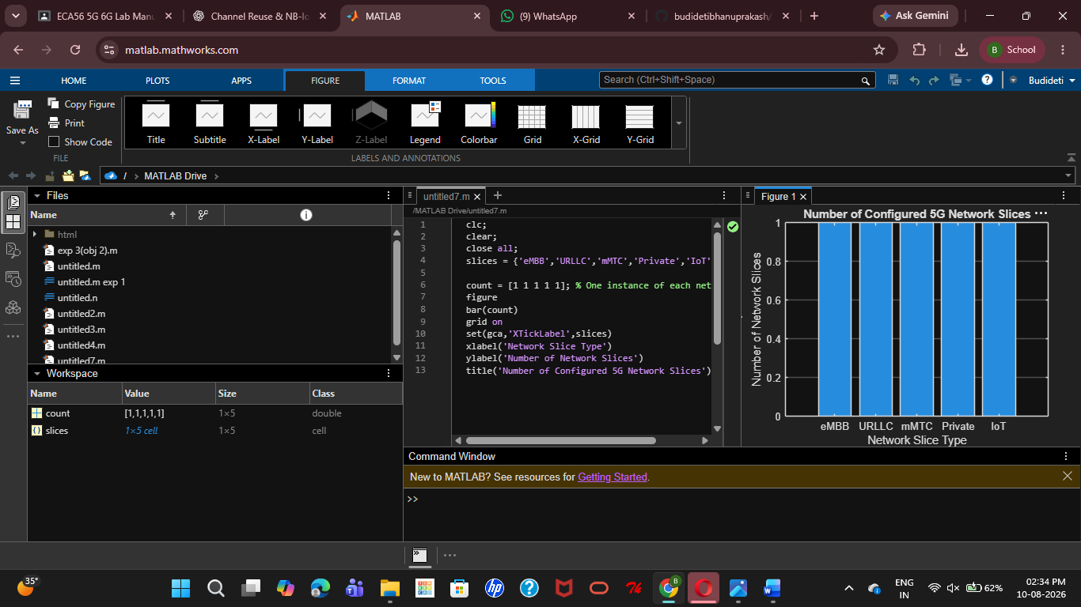
Objective 2:
Program:
clc;
clear;
close all;
slices = categorical({'eMBB','URLLC','mMTC','Private','IoT'});
utilization = [85 70 60 75 50];

figure;
bar(slices, utilization);
grid on;
xlabel('Network Slice Type');
ylabel('Slice Utilization (%)');
title('Slice Utilization in 5G Network Slicing');
ylim([0 100]);

Output:
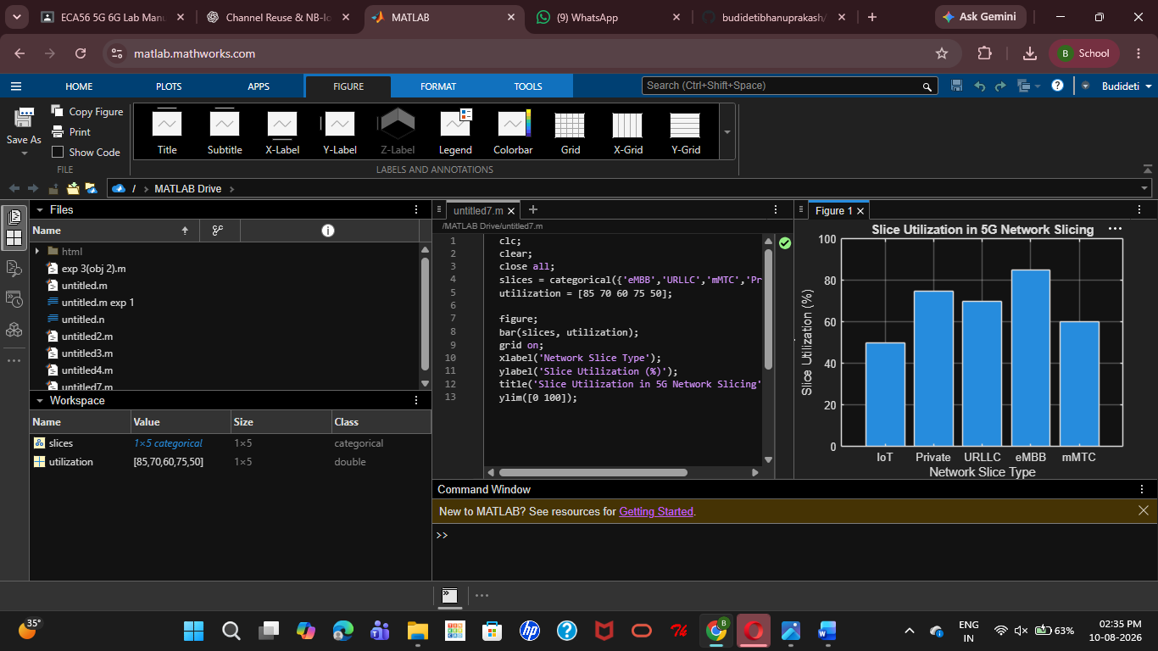

Objective 3:
MATLAB Code:
clc;
clear;
close all;
slices = [1 2 3 4 5];
latency = [25 5 40 15 60];
figure;
plot(slices, latency, '-o','LineWidth',2,'MarkerSize',8);
grid on;

xticks(slices);
xticklabels({'eMBB','URLLC','mMTC','Private','IoT'});
xlabel('Network Slice Type');
ylabel('End-to-End Latency (ms)');
title('5G Network Slicing: End-to-End Latency');
ylim([0 70]);

Output:
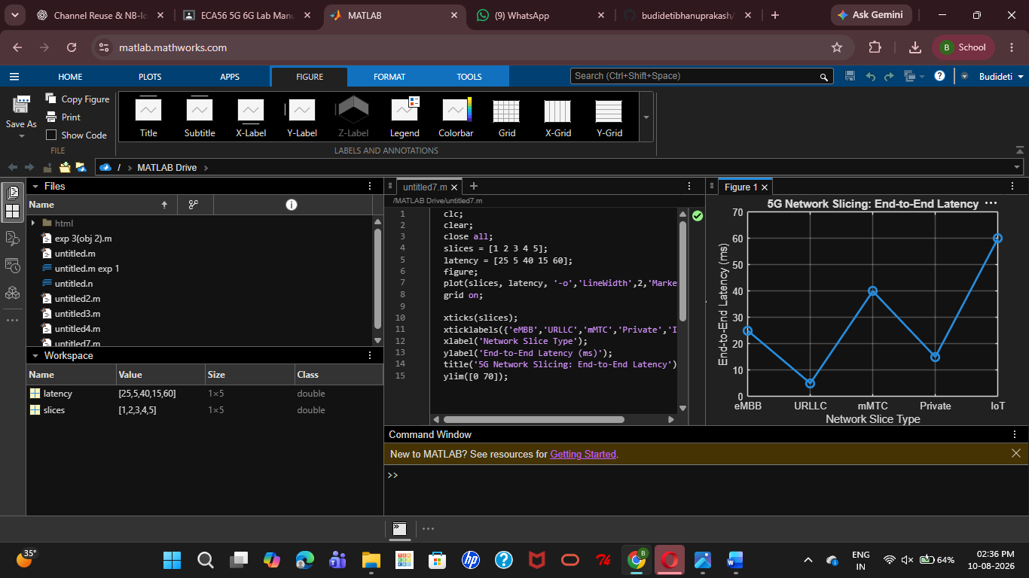
Result:
The 5G network slicing environment was successfully analysed in MATLAB, showing that multiple slices can be efficiently allocated, resource utilization can be compared, and end-to-end latency varies according to the QoS requirements of different 5G services.

